**HOSTING A STATIC WEBSITE USING AMAZON S3 BUCKET**

Organization “Z” have decided to host their static website on Amazon, and I have been asked to carry out the process. The developer has given me the source code for the website.

**Organization Z wants an HTTP website.**

Here is how I hosted Organization Z’s static website on Amazon

First, I had to create a S3 bucket for the souce code.

***Because this was going to be a public facing website and the public will be accessing it, I enabled ACL and disabled the option to block public access to the bucket.***

***Sometimes malicious actors delete or modify an organization’s source code and thereby making the website unavailable or defaced, to avoid losing the source code for this project I enabled bucket versioning. In case the source code was deleted or modified either intentionally or mistakenly, we can recover the previously uploaded data.***

***Next, encryption was enabled, and the bucket was created.***

***After creating the bucket, the next thing I did was to upload the source code I got from the developers****.*

Amazon S3 buckets have the static website hosting feature automatically disabled, this feature can be found under the properties tab for the bucket. I enabled staic website hosting and added the filename for home/index page.

***After enabling the static website feature, we then get a link that can be used to access website***

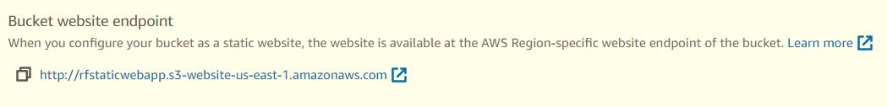

***Next, granting the public access.***

**This can be done by writing a bucket policy…**

**Or using the ACL that was previously enabled**

***The ACL could also be edited, and public read access granted***

A warning comes with taking this action.

***Pasting the link on browser returns our webpage and users can now interact with organization Z’s website.***

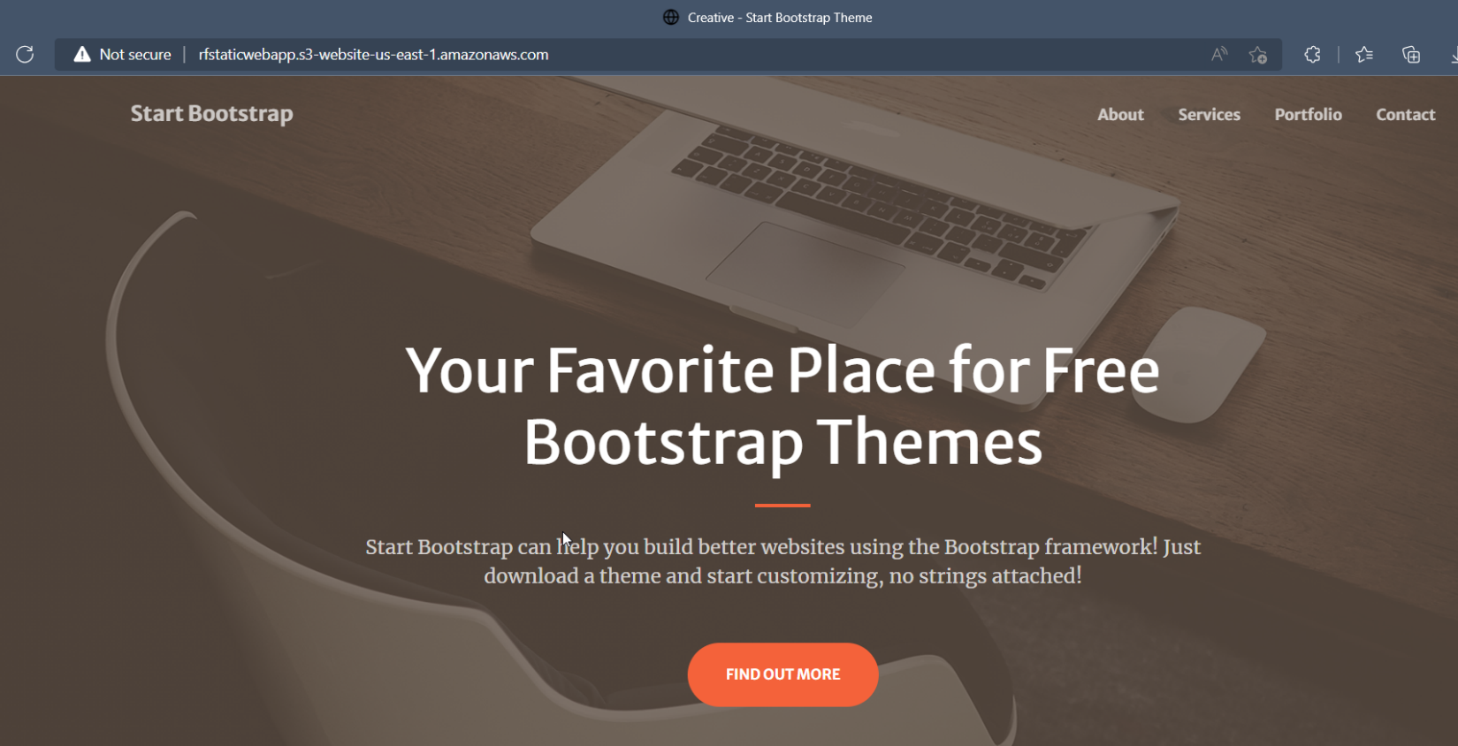

***CONCLUSION:***

A custom domain can be registered using **ROUTE53** on amazon and an entirely different method can be used to host a HTTPS static website on amazon.

Using **CloudFront and S3 bucket**.

**CloudFront supports HTTPS while amazon S3 website endpoint doesn’t**.

So CloudFront can be used to serve the static website hosted on Amazon S3.